This document serves as a list of requirements and considerations for weather data in APSIM NextGen for use in the Soybean Yield Gap Analysis project.

Drafted by Sam Wallace 7/25/2024

**APSIM NextGen Weather Data Requirements:**

The following screenshot is from the APSIM website about weather data:

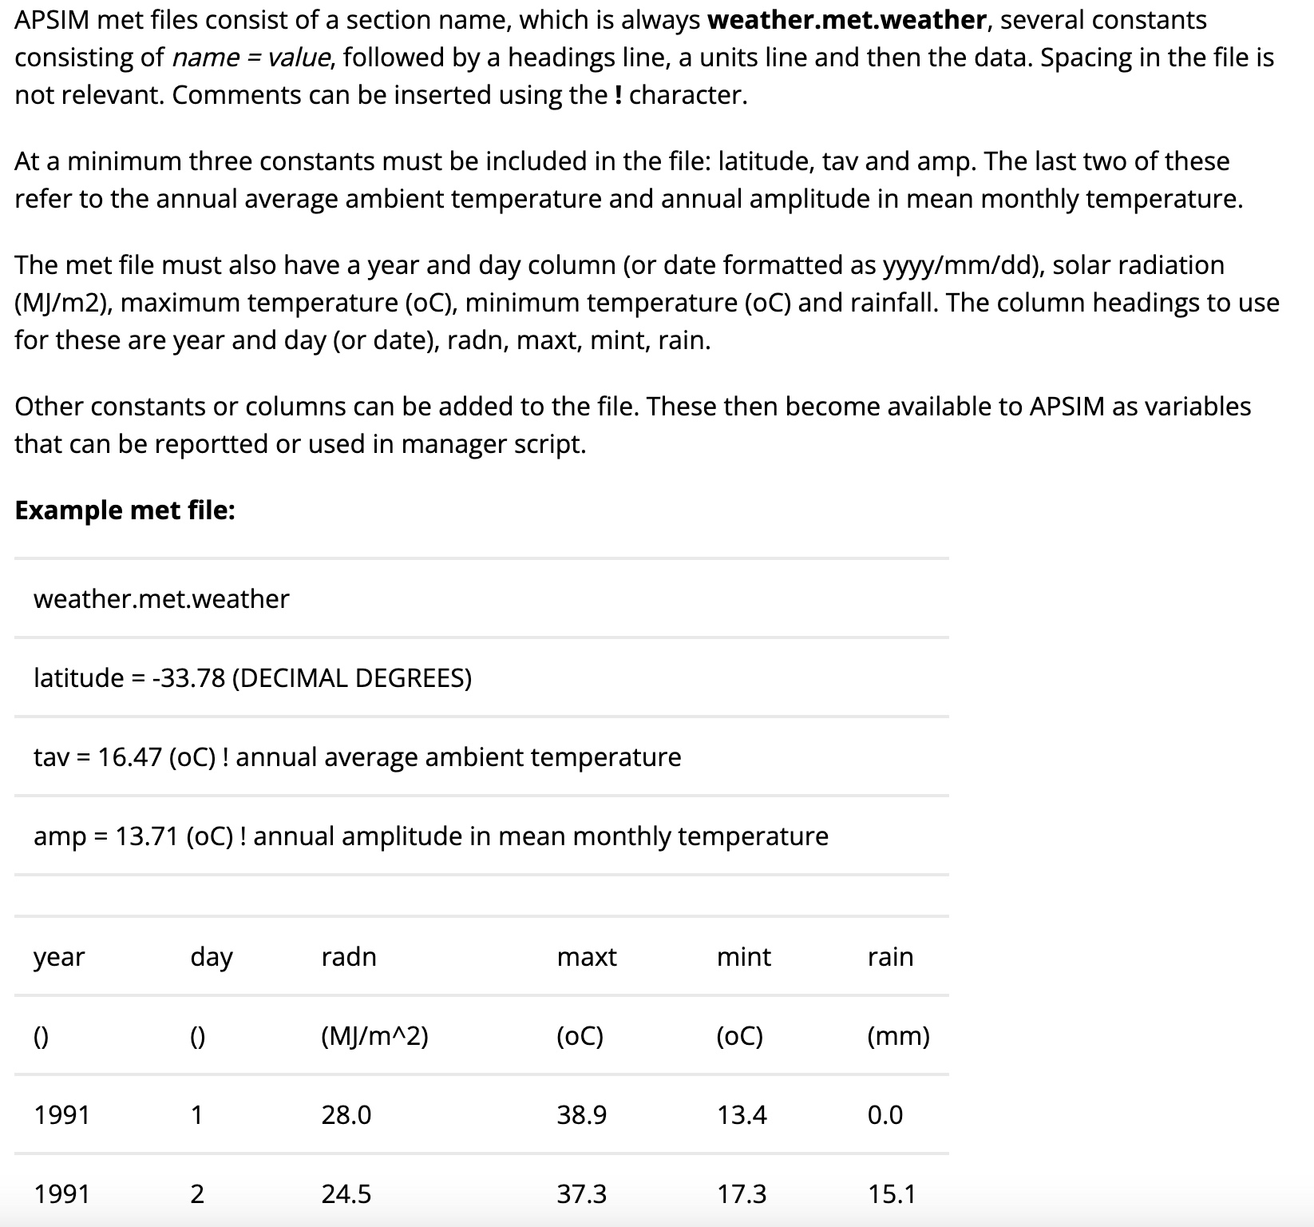

The link for the website is [here.](https://www.apsim.info/support/apsim-training-manuals/creating-an-apsim-met-file-using-excel/)

**Weather Data Source Considerations:**

|  |  |  |  |
| --- | --- | --- | --- |
| **Source** | **Variables Included** | **Missing Variables** | **Additional Notes** |
| NEWA | Max temp., min temp., precip., solar radiation | None | * For Musgrave data only goes back to 2022;Geneva only to 2019 * Requests can only be made within one year at a time |
| CLIMOD2 | Max temp., min temp., precip. | Solar radiation | * Data available for entire length of experimental period |
| Daymet | Max temp., min temp., precip., solar radiation | None | * All data on a 1km*1km grid from 1983-present * Some calculation required for variable input into APSIM * Only used for North America |
| NASAPower | Max temp., min temp., precip., solar radiation | None | * Easy to access in APSIM or R * Spatial resolution is different for each variable and based on remotely sensed satellite data |
| NY MESONET | Max temp., min temp., precip., solar radiation | None | * Data has request cost * Sites closest to Musgrave and Geneva are in Scipio Center and Waterloo respectively |

Based on this comparison table, I think it would be best to either utilize Daymet. NASAPower, CLIMOD2, or a combination of the two possibly could also be used if Daymet proves difficult to use. The temporal restrictions rule out NEWA as a good source for the experimental time period and MESONET has an interesting way of requesting data. NASAPower and CLIMOD2 are both very easy to access data from and an R script can be created to process the data into useable weather data in APSIM or other uses.